**Diff b/w Constraints & Validate Rule & Edit Validate**

**Constraints:  Everywhere same Validation ( Fixed)**

* **Dependency Validation**
* **Client Side Validation ( On Browser Refresh)**
* **We use functions to define validation**
* **No Need to call validation any where**

**Validate Rule: On some specific page**

* **Straight forward Validation**
* **Server Side Validations ( On Submit of Page)**
* **We use functions to define validation**
* **This will validate only one form on which it is called**
* **Validate rule will be called from Validation tab / Activity Method ( Obj-Validate)**

**Edit Validate:  ( Also called as Advanced Validations)  - Fixed /Specific to Page**

* **Using functions if unable to define any validation then go for Edit-Validate**
* **Edit Validation is  ( Fixed or Specific to Page)**
* **Straight Forward Validation**
* **Client & Server Validation**
* **Edit Validate is a Data Model Rule**
* **We need to write Java Source code**
* **Validate Rule will be called from Property-> Advanced Tab ( Use Validate) & Using Activity Methods ( Page-Validate & Property-Validate)**
* **Pega has built-in Edit Validate Rules & We can also add User Defined Edit Validate Rules**

**Working with Edit Validate Rule:**

**Req: Add Edit Validate for Age:**

**- If Age < 25 display Message that Minors not eligible**

**- If Age > 75 display message that seniors not eligible**

**Open Edit Validate Rule: IsNonNegativeInteger**

**Type above rule name in the Search Box**

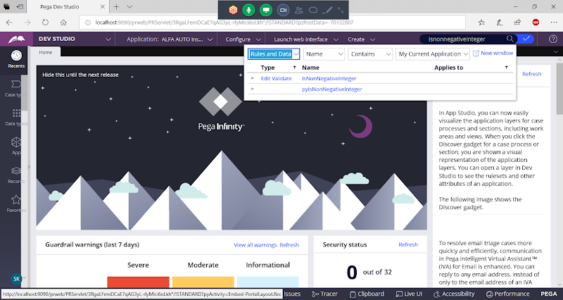

**Click on Rule to Open**

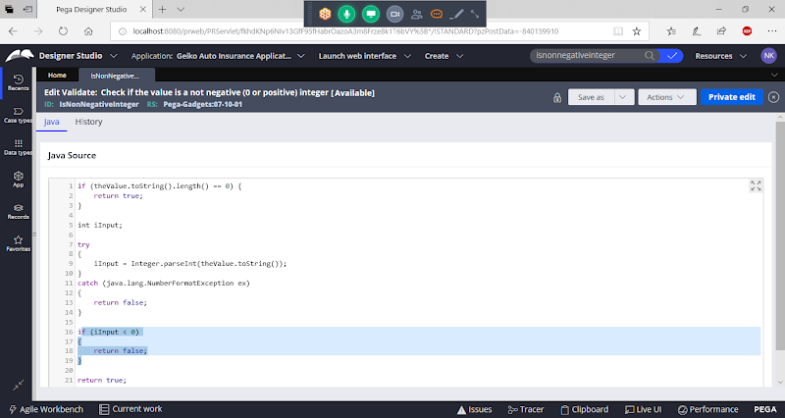

**Use saveas option**

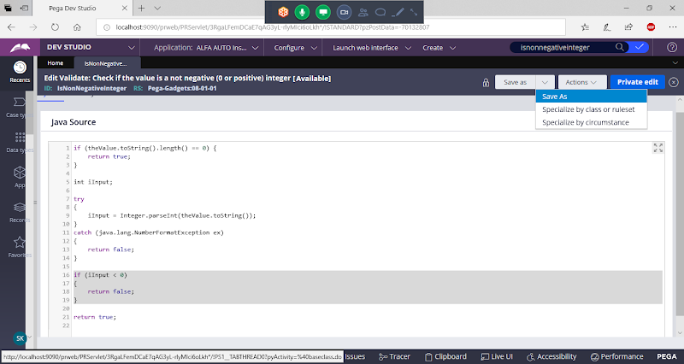

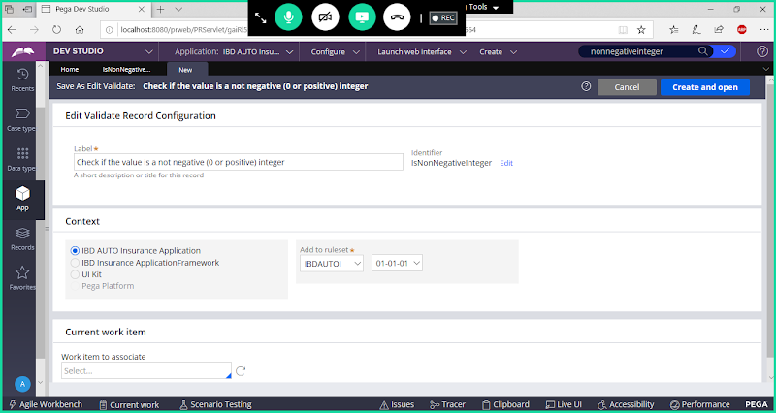

**Update Label/Rule Name**

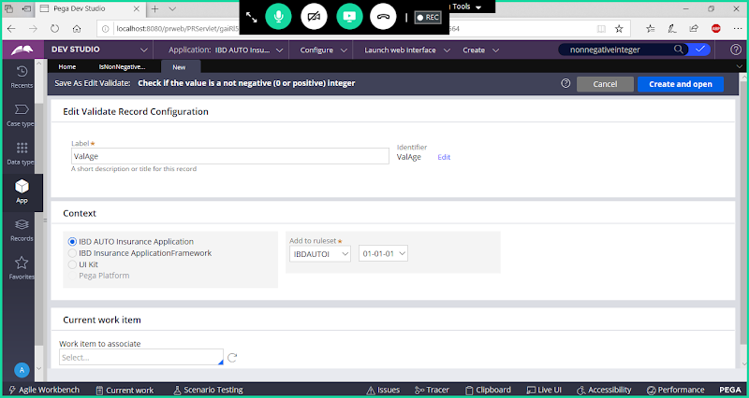

**Open Rule**

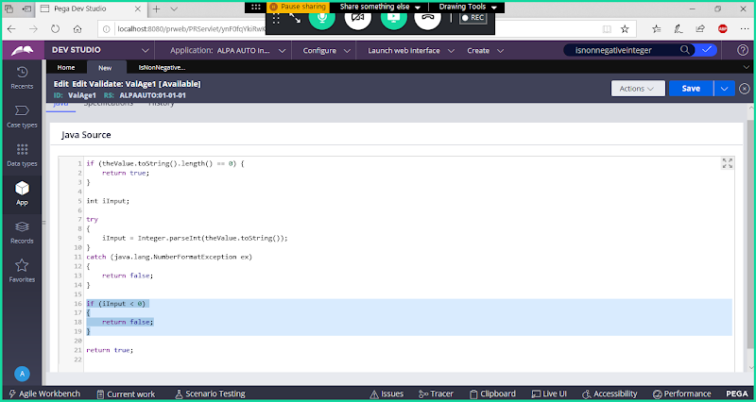

**Update Below Code in the highlighted portion:**

**if (iInput < 25)**

**{**

**theProperty.addMessage("Minors Not Eligible");**

**return false;**

**}**

**if (iInput >75)**

**{**

**theProperty.addMessage("Seniors Not Eligible");**

**return false;**

**}**

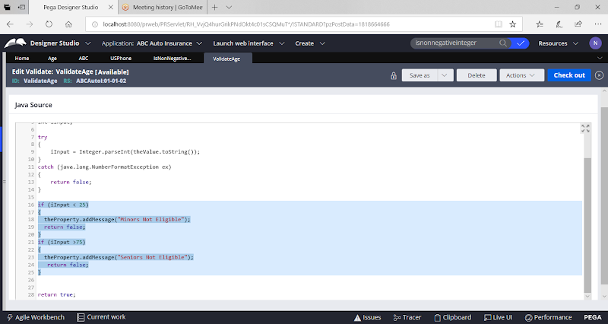

**Save Edit Validate Rule**

**Now Open Age Property & Go to Advanced Tab:**

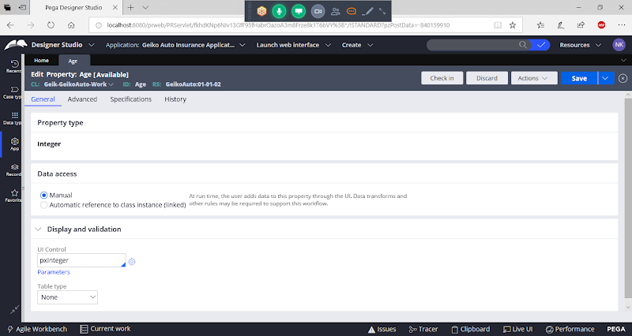

**Go to Advanced tab:**

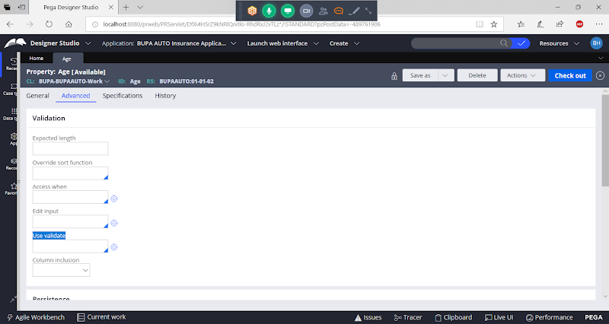

**Under Use Validate Call Edit Validate Rule Name**

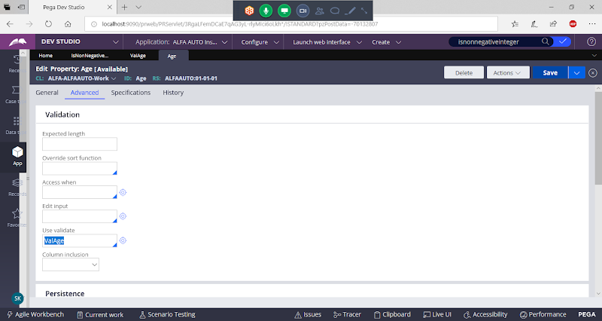

**Save Age & Check in**

**Run Customer Flow**

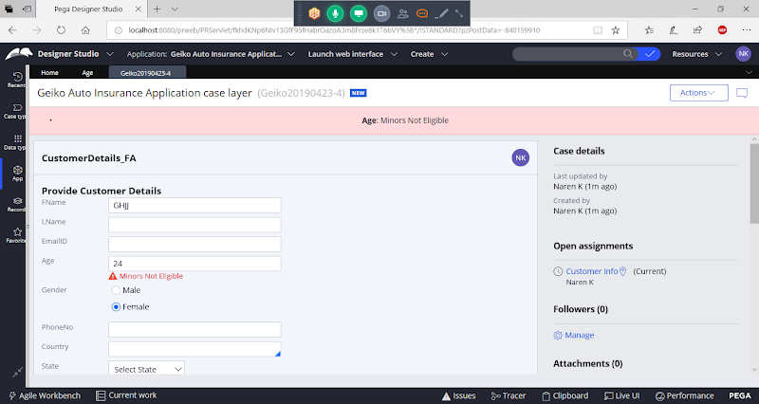

**How to Call Edit Validate in Activity:**

**Property -Validate:  We don't add step Page**

**Page - Validate: Specific to Page**

**=======**